The adoption of Lilka

***Introduction***

Today we are going to tell you the story about the adoption of Lilka, the puppy ,which belongs to the Deputy of TCoA - Anonka Milena. We hope that this article will make you inspired to share the stories of your little ones <3

Anon Milena has the experience in voluntary work, because she worked for Nobel Gift(one of the largest, most recognizable and effective social schemes in Poland) before, providing a support for people in need. It has awaken an extraordinary sensitivity to the needs of others( including animals) in her what prompted her to adopt the sweet little thing and soon support ANON.

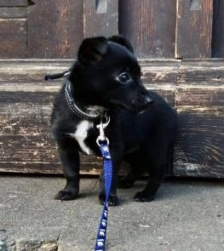

Lilka after the adoption

Wasn’t she tiny and very cute? However, despite a very young age, on the day of the adoption Lilka had already had a hard time behind her. At first, the puppy was close to her mom, but the owners quickly made the decision to donate the pet. Naturally, the first takers appeared and took the puppy from mom to a new, strange house for a few days

... and gave her back, because "the dog was barking". Lilka, hurt by people so early in her life, came back to the first home of her, waiting for what another days brought.

Fortunately - it brought her Anon Milena, who, as she declares herself, loves the dog very much, as we can see on their photo which is attached as a proof ☺

Now, Lilka is much older, looks like a real young lady and most importantly she is happy. No one will hurt her anymore.

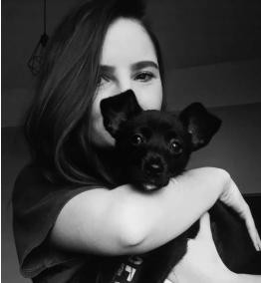

***Description***

*Treating animals objectively is a serious problem that contributes to suffering - Anonka Milena.*

It's hard to disagree with that. The current attitude towards animals has very old roots. It started to work out ever since Homo sapiens had made the first contact with them, so over 200 000 years ago (this is how old our species is).Throughout this time, the man has been taming, adapting, transforming and creating the new species of animals. Such a power has led to believe that animals are the inferior creatures, under our authority.

The embodiment of this approach is seen in today's law, because in accordance with its letter, a pet is not a household member or a companion, but a property of the owners.

Apart from that, a widespread trade proves that the humans treat them objectively – the fur industry, the food industry whether the pharmaceutical industry regularly acquire and process raw materials of animal origin. This frame of mind is not modern and does not take into account the current world of science achievement, which clearly indicates that animals are living creatures, capable of feeling the pain, having the emotions and their own intelligence (we are talking in particular about domestic animals). If we don’t pay attention to that, we lose sight of something very important - the similarities between us and them. If we were more focused on what unites us ,we would quickly see that the approach promoted in law, education and industry is wrong and the animals require more protection - especially those which share household with people. Although, we see the positive changes.

***Conclusion***

*The Amendment to The Animals Protection Act*

As an example of positive change, in September 2020, The Polish Government proposed The Amendment to the Polish Animals Protection Act (The Animal Welfare Act) . Its content contains a ban on ritual slaughter, a prohibition of breeding animals for fur and the restrictions related to holding domestic animals on a tether. What are those? Mainly, the use of chains and metal collars is forbidden now. Apart from that, the maximum time of holding the animal on the tether has been specified and is 12 hours per day( we still think that is a lot) So we see that something keeps changing. It changes for the better, but still too slow - not only in law, but above all, in consciousness of people.